
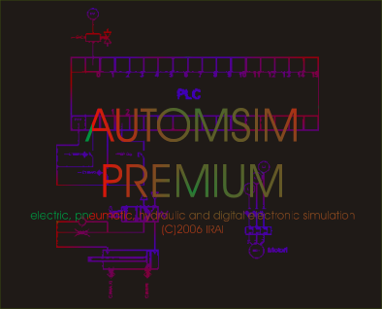
AUTOMSIM PREMIUM
Manual
www.irai.com
© 2012 IRAI
Version 8

Introduction 5
Installation 5
License 5
Familiarization 6
Using AUTOMSIM PREMIUM 10
Opening an existing application 10
Adding an object onto the sheet 10
Using the palette 13
Selecting one or more objects 14
Moving one or more objects 15
Deleting one or more objects 15
Changing the orientation of one or more objects 16
Copying/cutting one or more objects to the clipboard 16
Pasting one or more objects from the clipboard 16
Changing an object’s properties 16
Exporting one or more objects 17
Functions 18
Interactions between the objects 18
Creating sensors associated with a cylinder 18
Advanced functions 20
Adding measuring points 20
Automatically dragging links 21
Adding a parts list 22

Introduction
AUTOMSIM PREMIUM is a digital electrical / hydraulic / electrical / pneumatic simulation module.

Installation
To install AUTOMSIM PREMIUM, insert the AUTOMSIM PREMIUM CD-ROM in the reader or download AUTOMSIM PREMIUM from the Internet site www.irai.com .

License
When you install AUTOMSIM PREMIUM, you have a 40-day period to register the license. Once this period is ended, AUTOMSIM PREMIUM will not work any more; however, you can always proceed with the registration so you will be able to run AUTOMSIM PREMIUM again. To register AUTOMSIM PREMIUM, go to the File / License menu and e-mail the user code supplied by AUTOMSIM PREMIUM to the address contact@irai.com giving your last name and first name as well as your organization’s co-ordinates and your order reference. We will send you a validation code which you will enter in the same menu (File / License). Note: user codes and validation codes have a 20-day validity period. In other words, there must be no more than 20 days between the time when AUTOMSIM PREMIUM gave you the user code and the time when you enter the validation code. Licenses can also be managed by a network license manager (refer to this module’s technical documentation for more information).

Familiarization

Let’s try a simple example: a cylinder + a distributor.

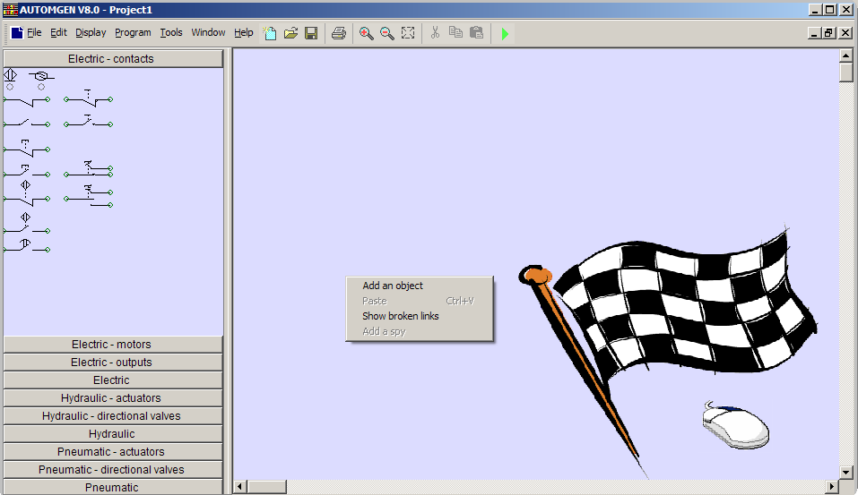
Right-click the mouse on the bottom of the main page, then select “Add an object”

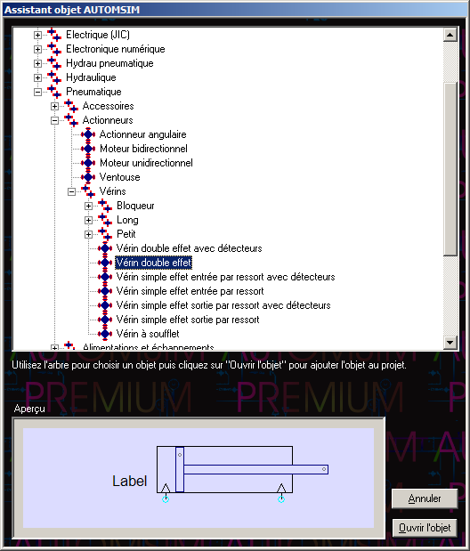

Select “double effect cylinder”, then click on “Open the object”.

Repeat the above steps to add a 4-2 distributor with monostable hand control, a power supply and a pneumatic exhaust.

You should get the following:
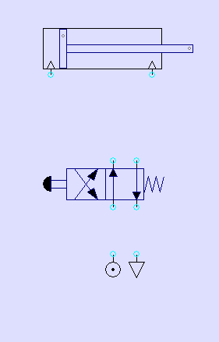

Create the connections between the different components: move the cursor over the connections (light blue circles), press the left mouse button then release it, move the mouse’s cursor to the connection where the link must be connected, press the left mouse button then release it.
Repeat this step for each connection until you get the following result:

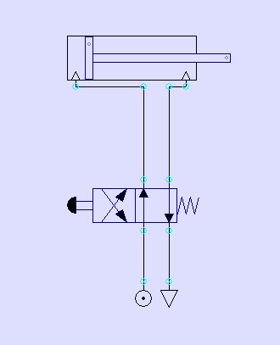

Click on the button in the tool bar.

The cylinder rod will come out. To make it go back in, click on the distributor’s manual control.

While it is running, you can make changes, add objects, move them, etc.

With AUTOMSIM, you don’t need to stop the simulation!

To end the simulation, click on .

Using AUTOMSIM PREMIUM

Opening an existing application

The sub-directory “Examples / automsim” of the directory contains some already prepared examples.

Adding an object onto the sheet

Right-click with the mouse on the page (shown below on the right) and select “Add an object”.

The object selection assistant then appears:

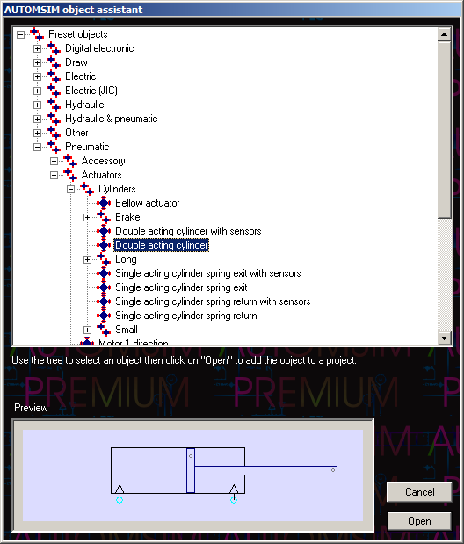

This assistant shows a preview of the object in the bottom of the window. To add the object onto the design area, click on “Open the object”.

Then move the mouse to position the object on the AUTOMSIM sheet then press the left mouse button and release it to leave the object.
You will get the following result:

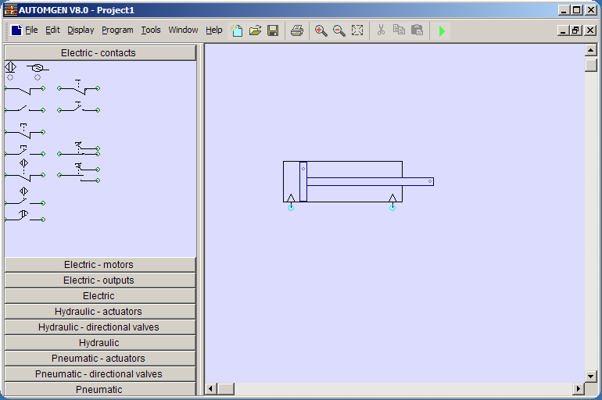

Using the palette

- click on the object(s) in the palette (they are shown as selected: framed by black squares).
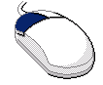

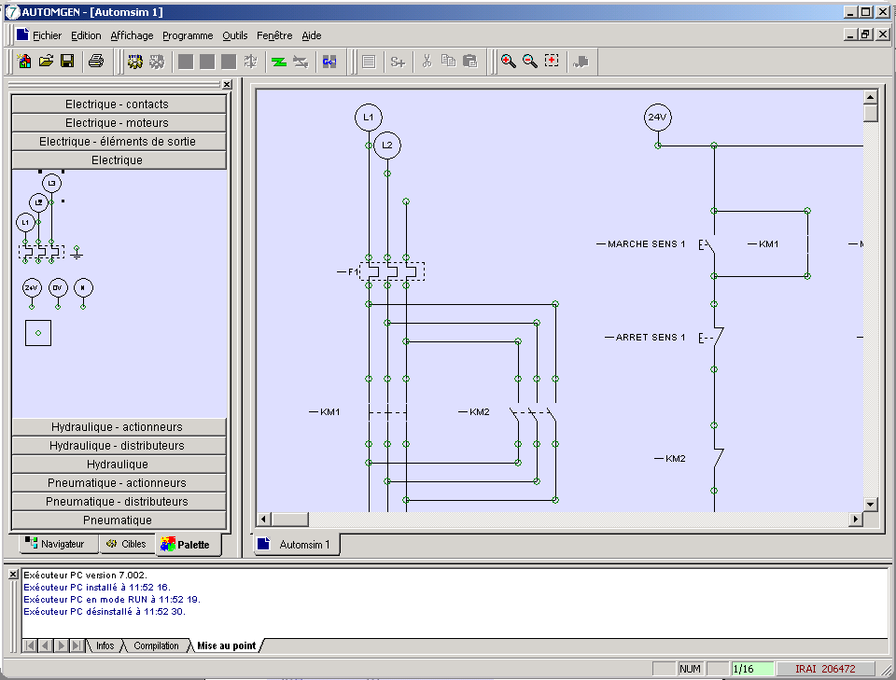

- click on the selected object(s), leave the button pressed and drag the object onto the sheet.

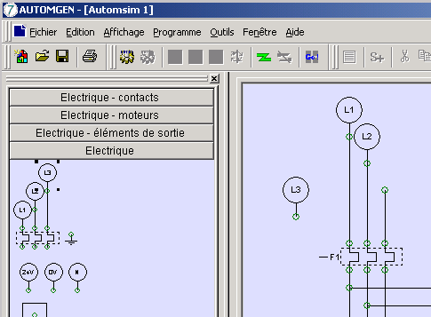

Selecting one or more objects

To select an object, move the mouse’s cursor over the object, press the left mouse button and release it. Black squares appear round objects when they are selected:

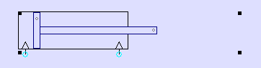
To de-select an object, repeat the same step.

To select several objects: keep the keyboard’s SHIFT key pressed and select several objects using the method described above.

To select several objects that are in the same area: press the right mouse button, move the mouse’s cursor – a selection rectangle appears – release the right mouse button when the selection rectangle is the size you want.

To select an object that is under another object (several objects can be superimposed) click several times with the left mouse button on the objects covering each other: with each click, the selection moves from one object to the next.

Moving one or more objects

Move the cursor over one or more selected objects – the mouse’s cursor display changes to four direction arrows – press the left mouse button, move the objects by moving the mouse, release the left mouse button when the objects are in the position wanted.

Deleting one or more objects

Move the cursor over one or more selected objects, press then release the right mouse button and select “Delete”.

Changing the orientation of one or more objects

Move the cursor over one or more selected objects, press then release the right mouse button and select the wanted setting in the “Rotation” menu.

Copying/cutting one or more objects to the clipboard

Move the cursor over one or more selected objects, press then release the right mouse button and select “Copy” or “Paste”.

Pasting one or more objects from the clipboard

Move the cursor over one or more selected objects, press then release the right mouse button and select “Paste” from the menu.

Changing an object’s properties

Move the cursor over one or more selected objects, press then release the right mouse button and select “Properties”.

Example of the properties of a directional valve:
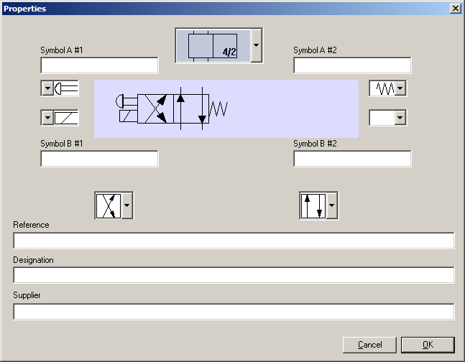

Exporting one or more objects

Move the cursor over one or more selected objects, press then release the right mouse button and select “Export”.

The objects are exported to files with the extension .ASO.

By exporting to the sub-directory “automsim/lib” of the AUTOMSIM PREMIUM installation directory, the new objects created appear in the assistant. The file name is the name displayed in the assistant. If the name must contain the character ‘/’, replace this character by ‘@’ in the file name.

Functions

Interactions between the objects
Interactions between AUTOMSIM PREMIUM objects are realized either by visual links defined on the page (e.g. a pneumatic or electrical line connecting two objects) or by a symbol. A symbol is a generic name, e.g. “mini sensor”.

Creating sensors associated with a cylinder

The mini and maxi end stops of a cylinder can be configured in the properties of the cylinder. For example:

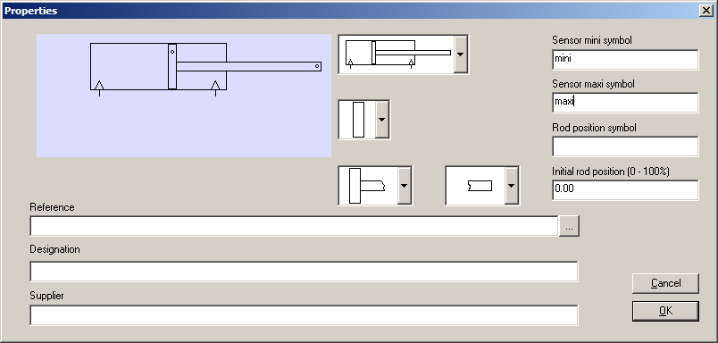

References for the symbols used can be found in the electrical contacts.

For example:

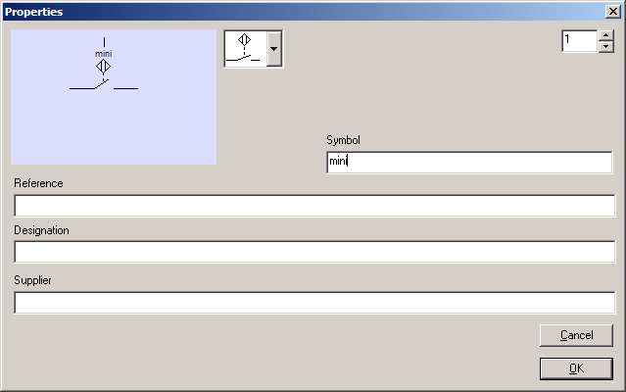

The sensors can also be positioned directly on the page. For example:

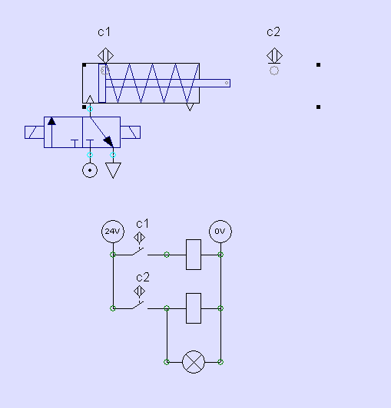

The grey circle associated with the sensor objects must coincide with the grey dot located on the piston or cylinder rod in order for the sensor to be activated.

Advanced functions

Adding measuring points
To add a measuring point, right-click with the mouse over a connection and select “Add a spy”.

The following window is opened:
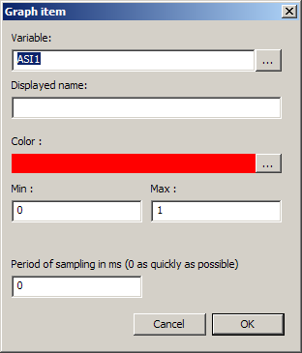

Adjust the different elements then click on OK.
The measurement window is opened:
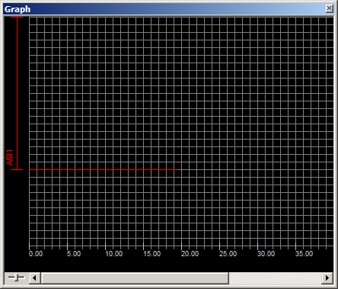

To change or add a measurement, right-click with the mouse on the left part of the measurement window.

The potentiometer in the bottom left of the measurement window allows you to adjust the time scale.

By moving the line displayed on the left part of the measurement window by either of its ends, you can move or size the display area for each measurement.

Automatically dragging links
By keeping the SHIFT button pressed while you move an object, the links are automatically adapted.

Adding a parts list

To add a list of components, use the following object:

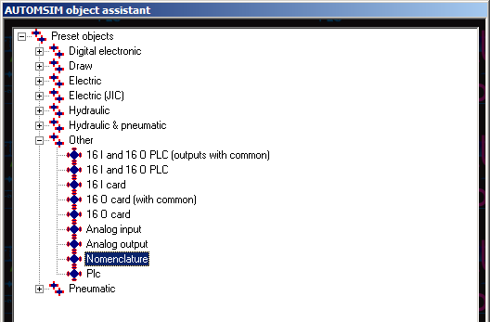

Then document the “Reference” and “Description” areas in the properties for each component.

Here is an example:

