# Vup models optimization

1. Triangles decimations

The purpose is to simplify the geometries. For your model, I have done it selectively, by example I did not use it for the tires because we saw that it modify the physic simulation.

For your project, I use the following on the following group of objects:

Right click on “A1” :

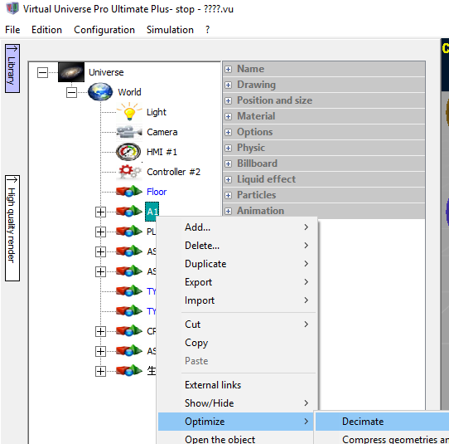

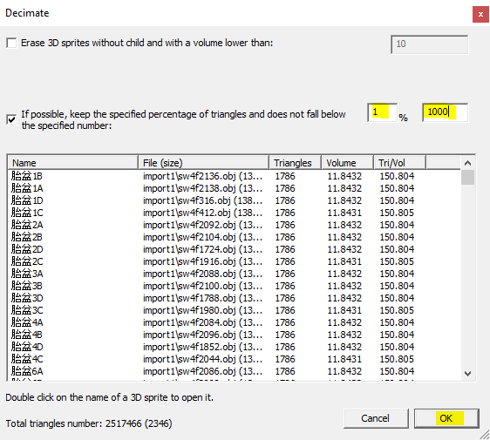

Click on OK.

Do the same for other items :

PLATFORM, ASRS CRANE, ASRS LOADSTATION, ASRS UNLOADSTATION,

1. Optimizing materials

The purpose of this optimization is to group geometries using the same materials (Eg. the same color). It dramatically increase the rendering speed. This optimization must be done only after the behaviors of the simulation ha been defined. Vup need to know which objects are fixed and which are moving to know which can be merged.

For your project, I use the following on the following group of objects:

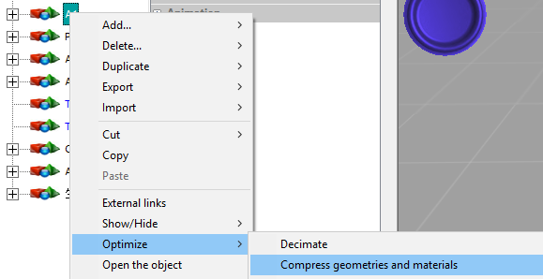

Do the same for other items :

PLATFORM, ASRS CRANE, ASRS LOADSTATION.,

1. Deleting ununsed medias

The purpose of this is only to reduce the size of the vup file and so the load and save process, it does not speedup the rendering.

Fo your project I did the following :

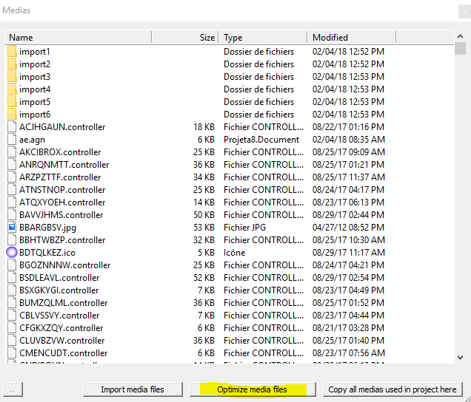

1. Other recommandations

Before exporting from Solidworks, a quality factor may be selected to generate less triangles, please use it to reduce triangles at the souce, it will speed up all the optimiis kind ofzation process.

For thhis kind of project, please use the 64 bits version to avoid crash due to memory limitation (4gb) of 32 bits version. I will generate a new 64 bits version and send you the link soon.

1. Conclusion

After these optimizations, the rendering time has been greatly decreased, the simulation should run smoothly, please check and tell me.

Here is your project after all the optimizations :

http://www.irai.com/friends/wilson/%e5%8d%a1%e9%a1%bf%e6%a8%a1%e5%9e%8b%20optimized%20final.vu

1. The worflow should be as following :

6.1- Depending on CAD software, set the export options to limitaed the triangles number,

6.2- Export from CAD software,

6.3- Import in Vup,

6.4- Decimate triangles,

6.5- Define behaviors,

6.6- Merge materials.

6.7- Delete unused medias.

To preserve the possibility to add new behaviors or modify, it is nice to make a save at point #6.5